TheErrorObject_And_CustomErrors

## Error Properties

Error.name

Error.message;

Error.stack

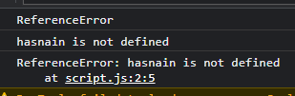

Use try and catch to catch the error and you can also send custom errors using throw keyword



# CustomErros

